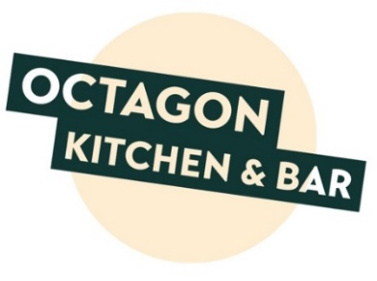

Specials Menu

STARTERS
BBQ Chicken Wings (gf)
with salad garnish
8.45
Duck Confit Salad (gf)
with orange caramel dressing with fresh orange segments 8.95
Moroccan Cauliflower (ve, gf)
served with a tangy tomato chutney
7.45

MAINS

Lamb Stew & Mint Dumplings with pickled red cabbage and bread & butter
16.95

Cajun Salmon (gf)
With salad, coleslaw and either roast new potatoes or chips
15.95

Vegetable Tart with Goats Cheese (v, vea)
Served with tomato sauce, salad and chips
13.45

(v) Vegetarian (ve) Vegan (vea) Vegan available (gf) Gluten free (gfa) Gluten free available

Not all ingredients are listed in our menu descriptions. If a member of your party has any allergies or dietary requirements, please speak to a member of staff who will be able to provide you with further information.

